`

NAME=BABITA KARMIYAL

DEPARTMENT=BCA(HLD)

UNIVERSITY.ROLL.NO=2092011

STUDENT ID=20042268

PYTHON PRACTICAL PROGRAMMING

INDEX:

|  |  |  |  |  |
| --- | --- | --- | --- | --- |
| SR.  NO | ASSIGN.  DATE | SUBM.  DATE | TITLE | TEACHER’S  REMARK |
| 1. |  |  | PRACTICAL.I |  |
| 2. |  |  | PRACTICAL.II |  |
| 3. |  |  | PRACTICAL.III |  |
| 4. |  |  | PRACTICAL.1V |  |
| 5. |  |  | PRACTICAL.V |  |
| 6. |  |  | PRACTICAL.VI |  |

|  |  |  |  |  |
| --- | --- | --- | --- | --- |
| 7. |  |  | PRACTICAL.VII |  |

PYTHON PRACTICAL QUESTION:I

#WAP TO PRINT YOUR NAME,AGE,ADDRESS,COURSE,SEMESTER

,ADDRESS,UNIVERSITY ROLL NO

,,

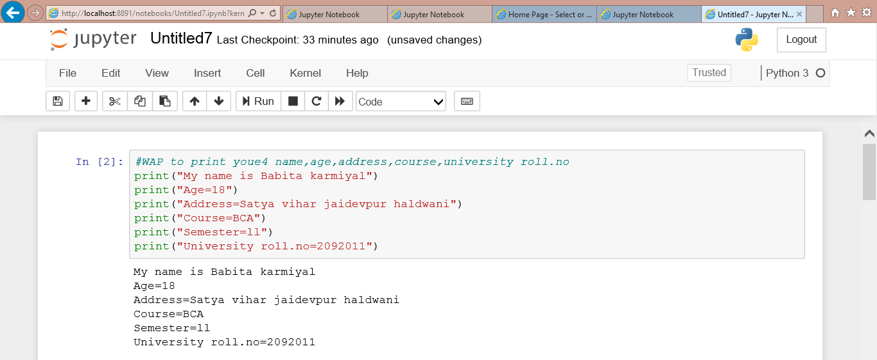

2.WRITE A PYTHONE PROGRAM TO SWAP TWO NUMBERS

WITHOUT USING ANY THIRD VARIABLE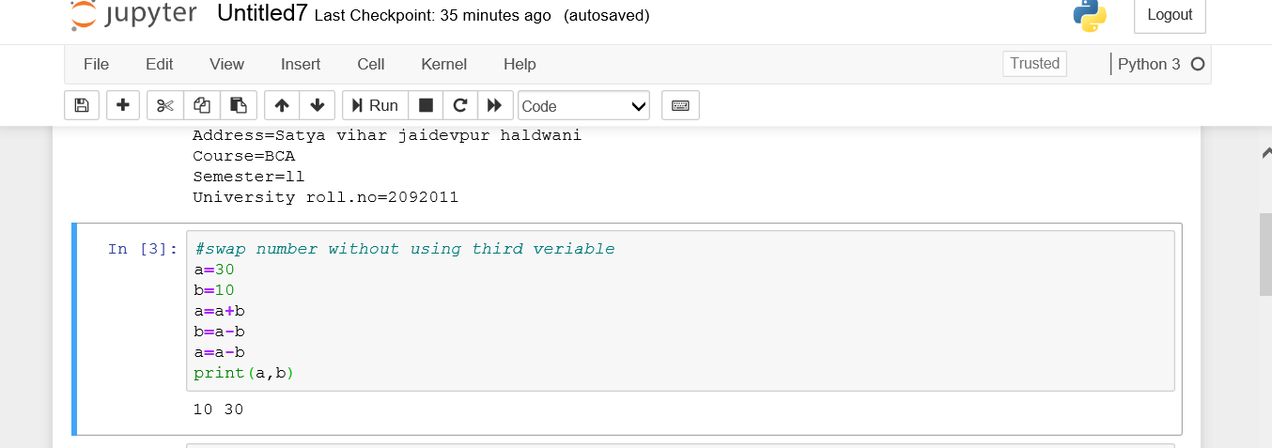

.WRITE A PYTHON PROGRAM TO PRINT THE TABLES OF 5 AND 10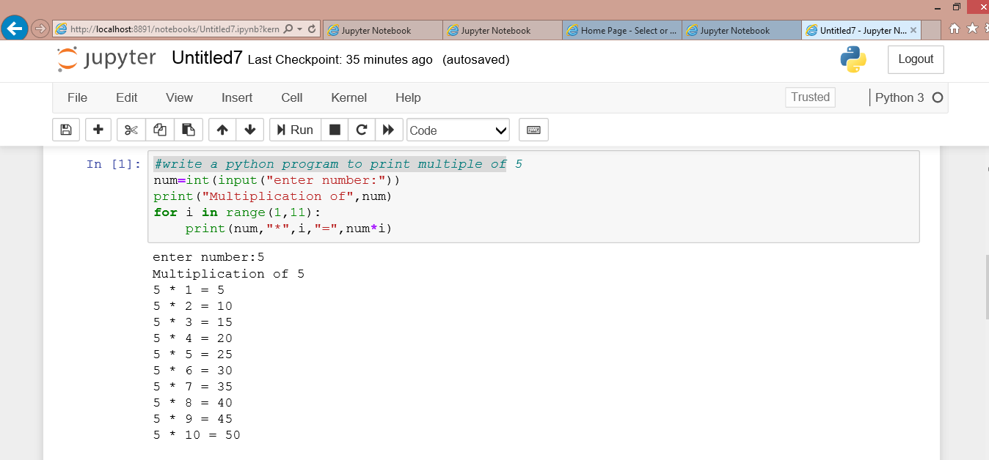

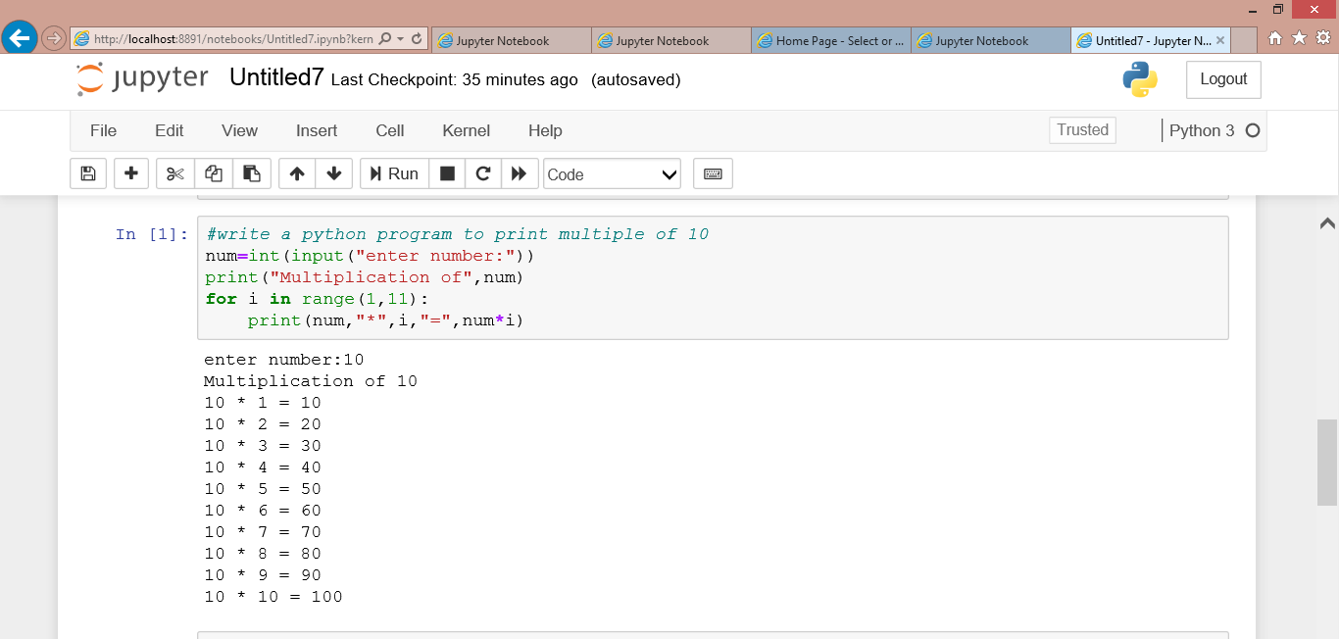 PYTHON PRACTICAL PROGRAMMING 2:

1.WRITE A PYTHON PROGRAMM TO PRINT “HELLO STUDENT HOW ARE YOU”AS”HOW ARE YOU HLLO STUDENTDS” FIVE TIME WITHOUT USING PRINT STATEMENT 5 TIMES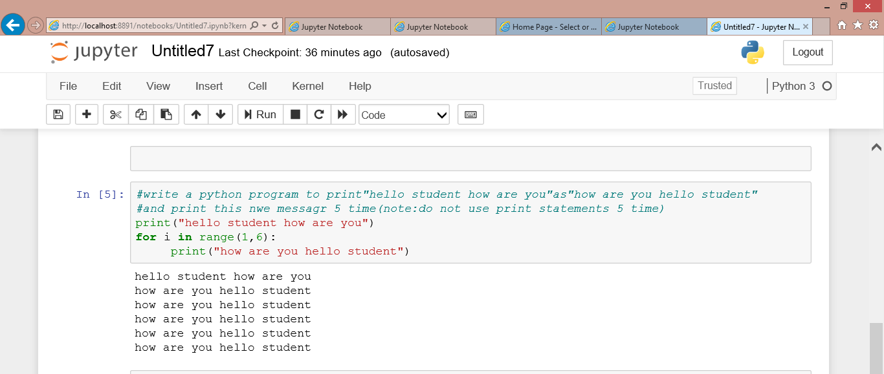

2.ASSUME ANY STRING WHICH CONTAINS”SECOND SEMESTER”,REPLACE IT WITH “THIRD SEMESTER”.ALSOCPRINT THE POSITION OF THIRS SEMESTER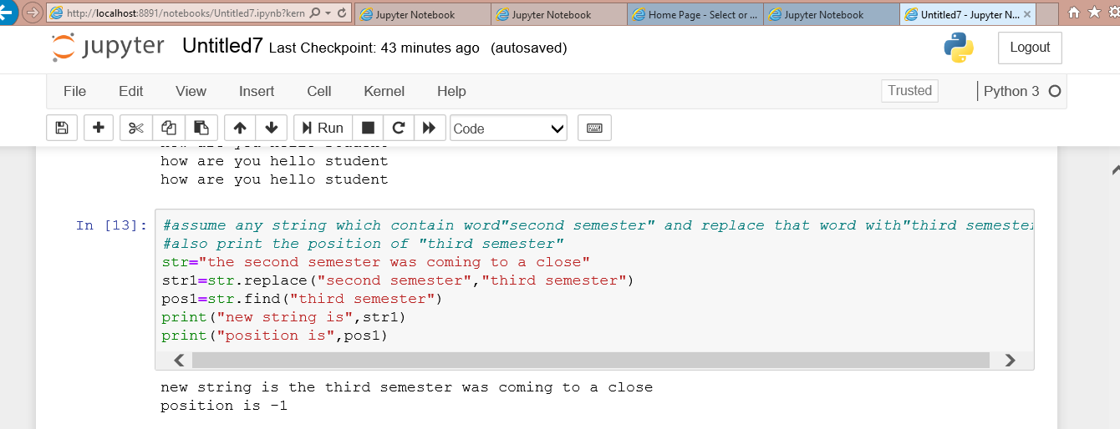

3.TAKE ANY STRING WHICH CONTAINS MORE THAN TWO LINS ABOUT YOU.NOW COUNT NUMBER OF TIMES”I” OCCURS IN THE STRING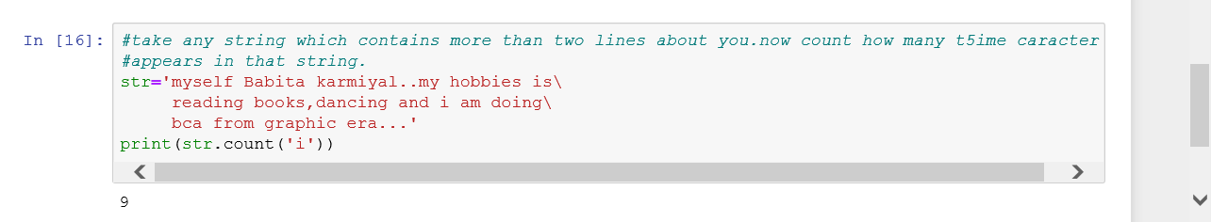

4.consider any long string .now replace the space between two words with the tab.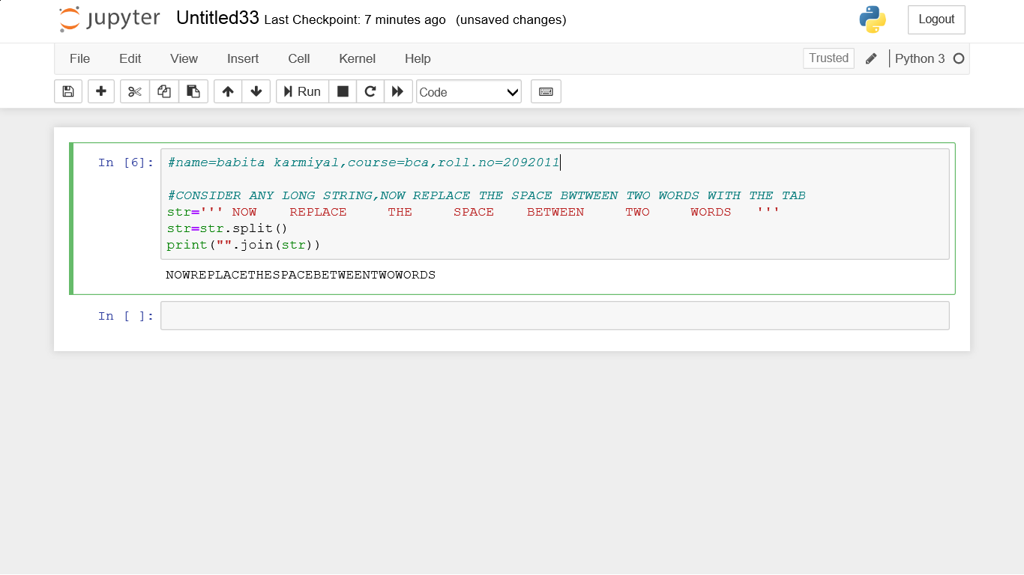

5.write a pyton program which can identify and print output whether a given string is a website name or not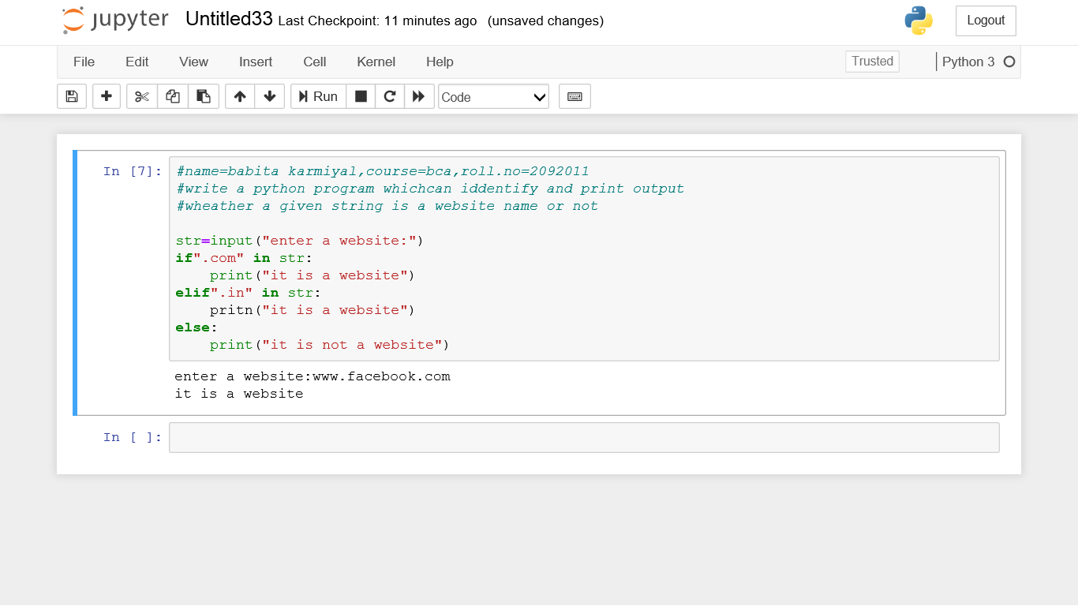

Python practical question;3

1.take any list and print it in following manner,

a)print onl;y last three element

b)print all valus except the first and last value

c)print only three element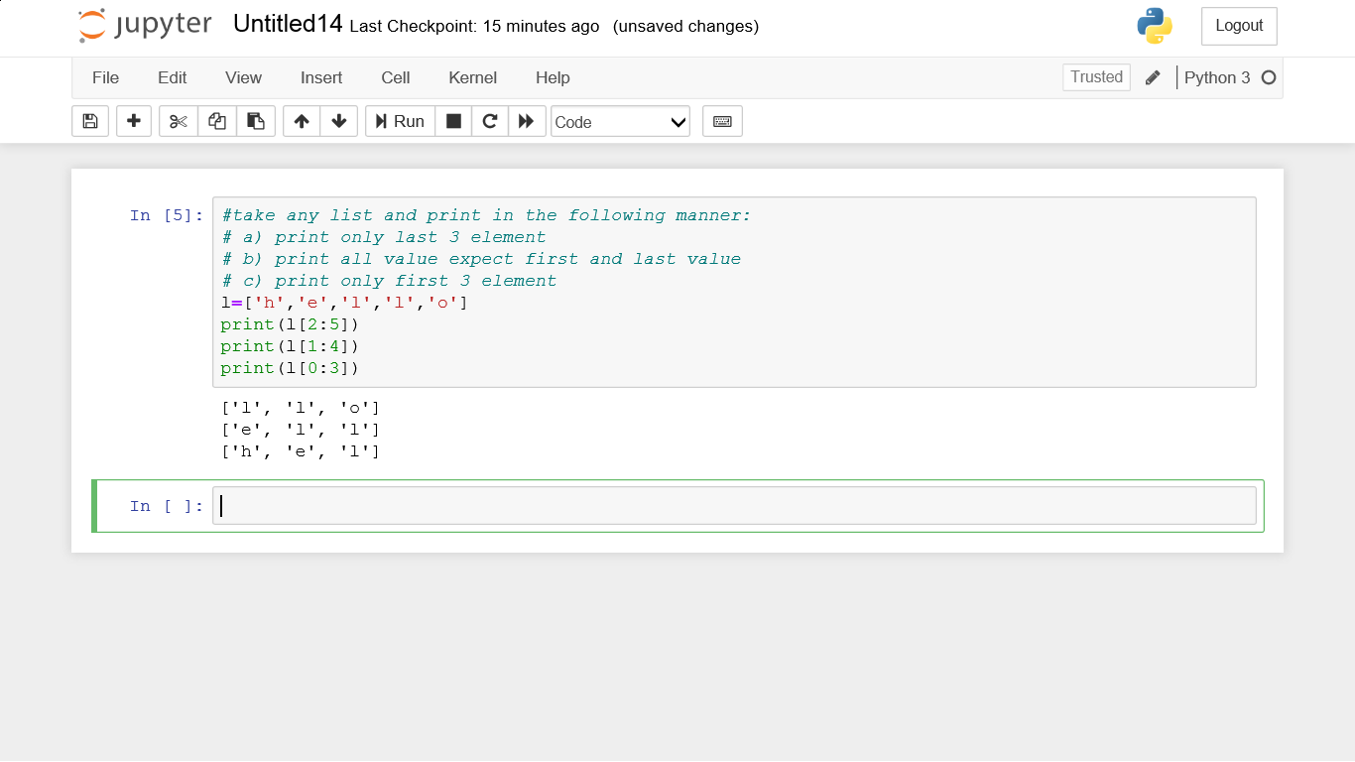

3.consider any tuple containing integer,decimal and string values.now delete all decimal values and then add three character values in it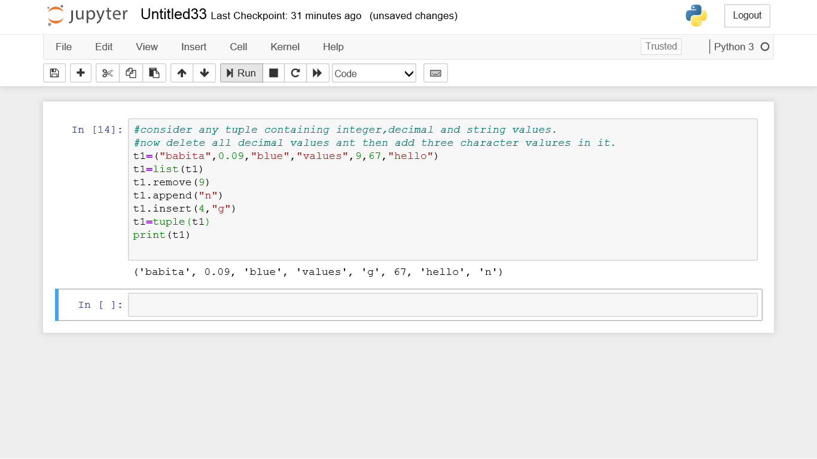

2.in a python consider any list containing integer,decimal and string values,now delete all decimal values using any list delete functions and then add three character in it.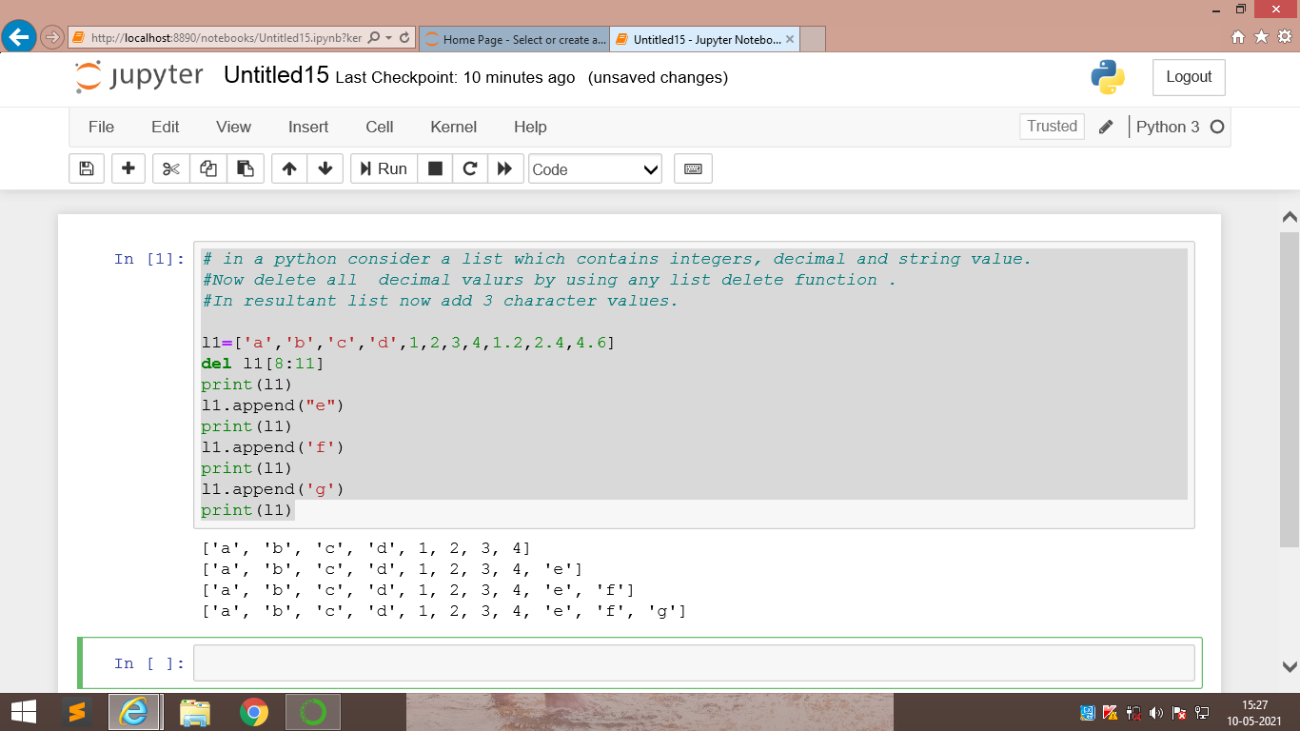

Python practical question:4

Make a dictionary in which the keys are the numbers and the values are their cubes. now first print the dictionary and then print th values of the dictionary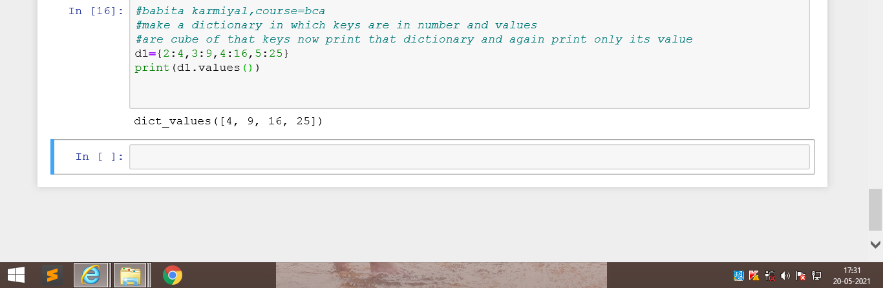

2.consider an existing dictionary with some existing values.first empty the dictionary and tn add some new key-value pairs to it.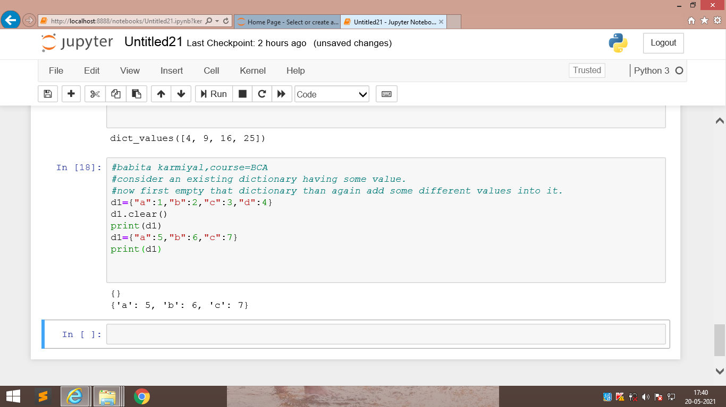

3.write a python program to check any 5 values that is present in an existing dictionary or not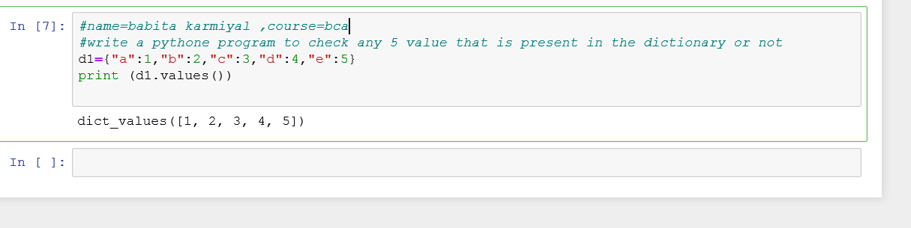

Python Practical question.5

1.write a python program to check if the value entered by the user is a palindrome or not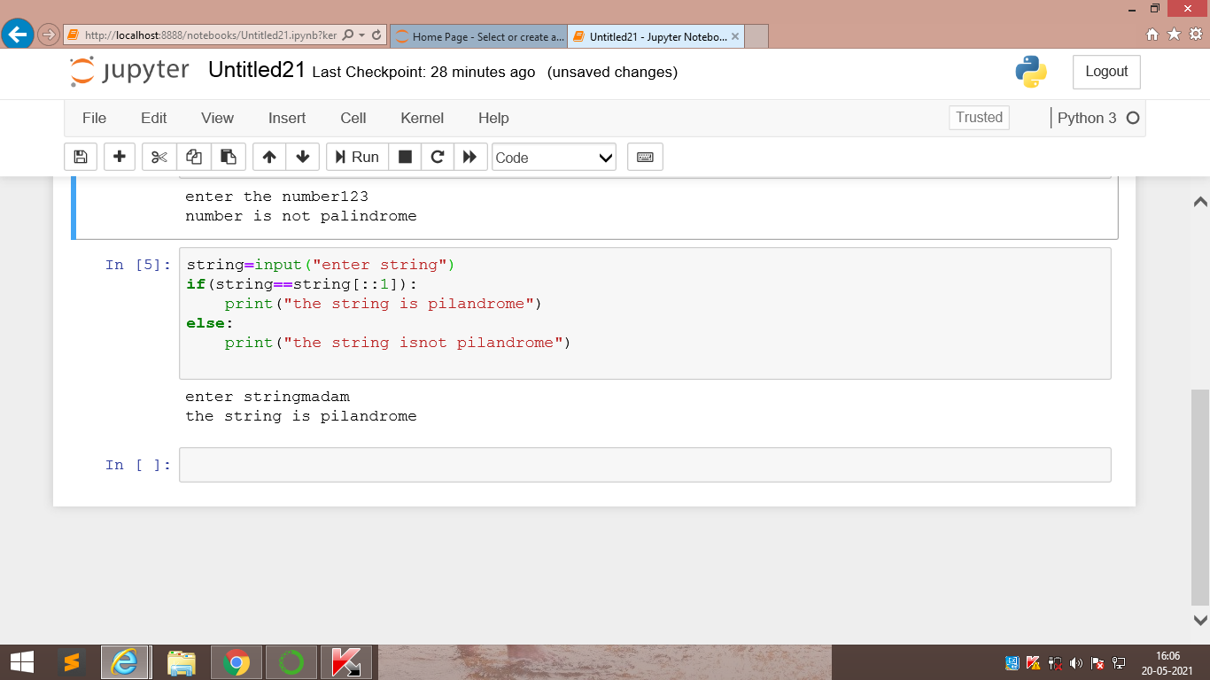

2.write a python program to check if the value entered by uses is a Armstrong number or not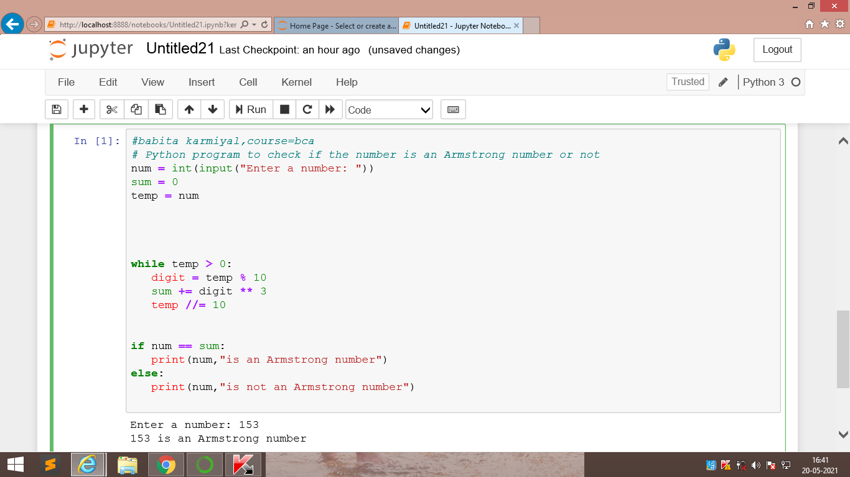

3.consider a numbr given input by the user .now find the factorial of the number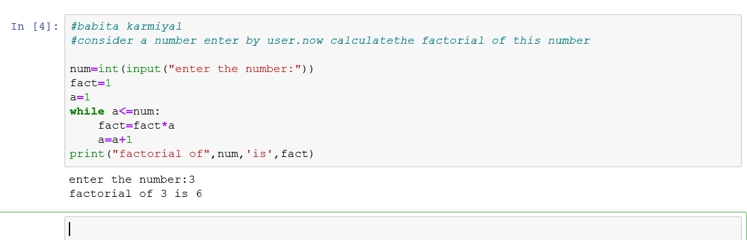

4.Write a python program to print the Fibonacci sequence upto the range given by the user.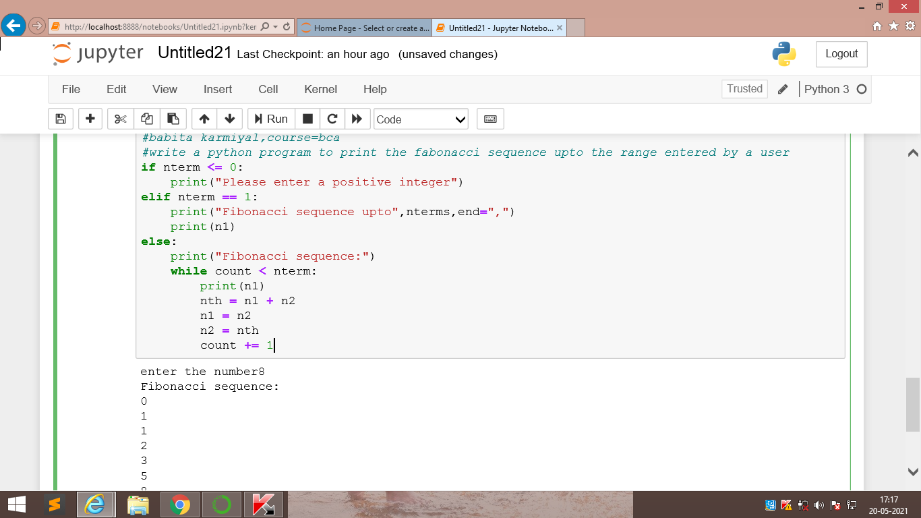

5.write a python program to chck whether th number entered by the user is a perfect number or not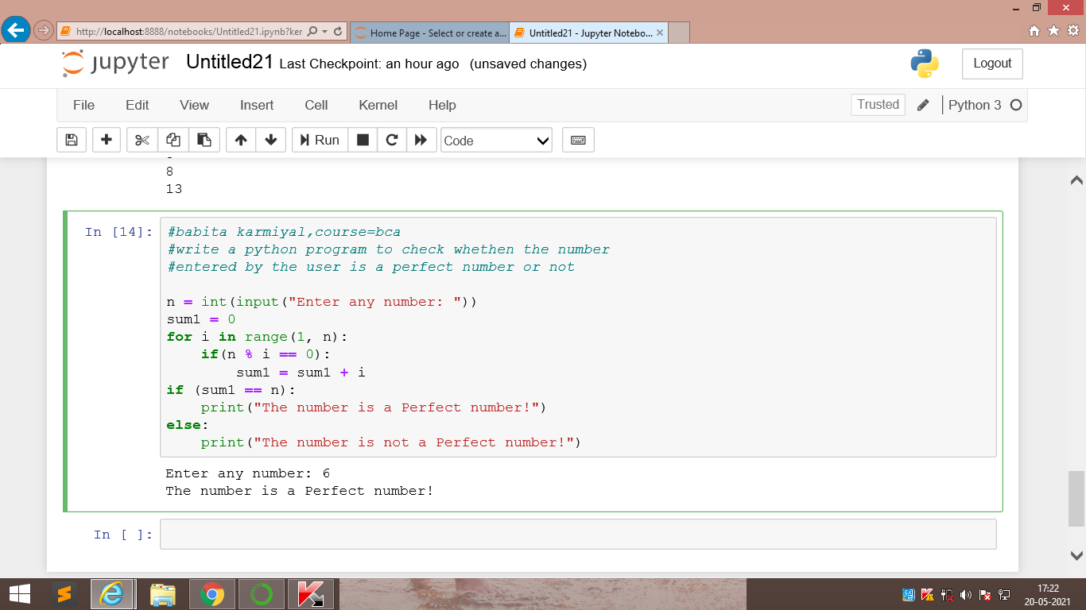

Python practical question.6

Write a python program to remove duplicate values from a list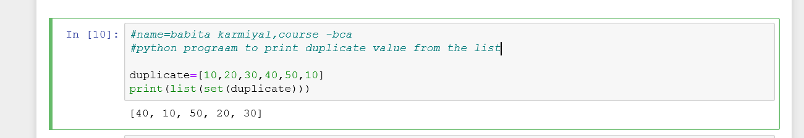

2.write a python program to get a string from the user and check if it start with “is”or not.if not then add is with it

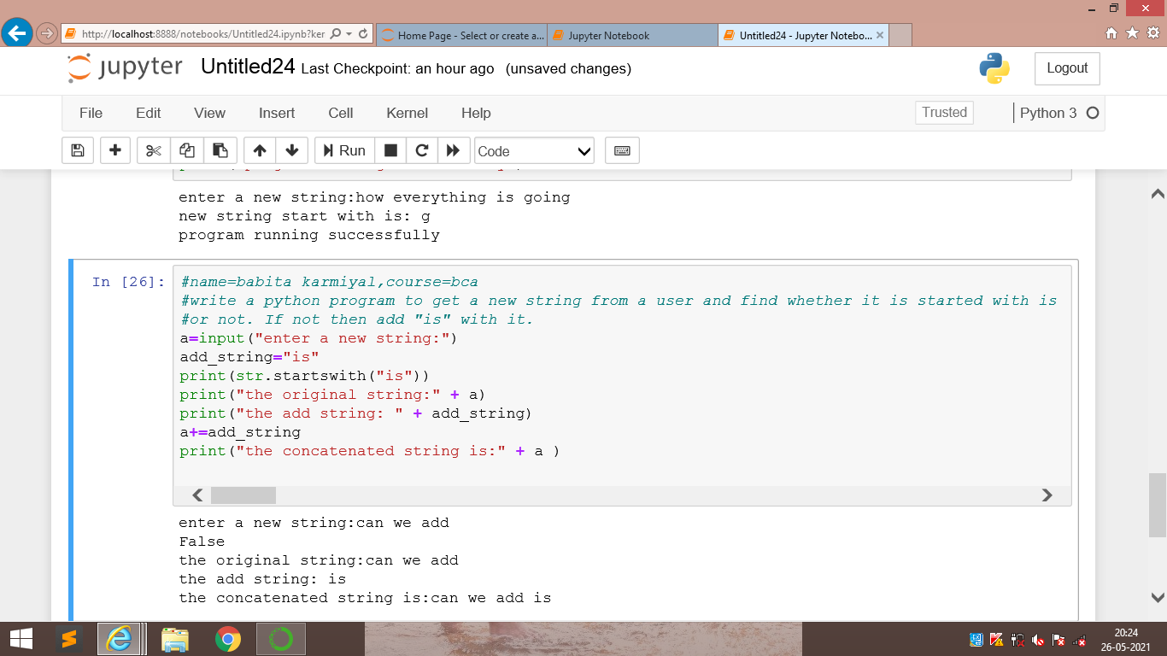

3.write a python program to count the number of alphabets ,digits and symbol in the string given by the user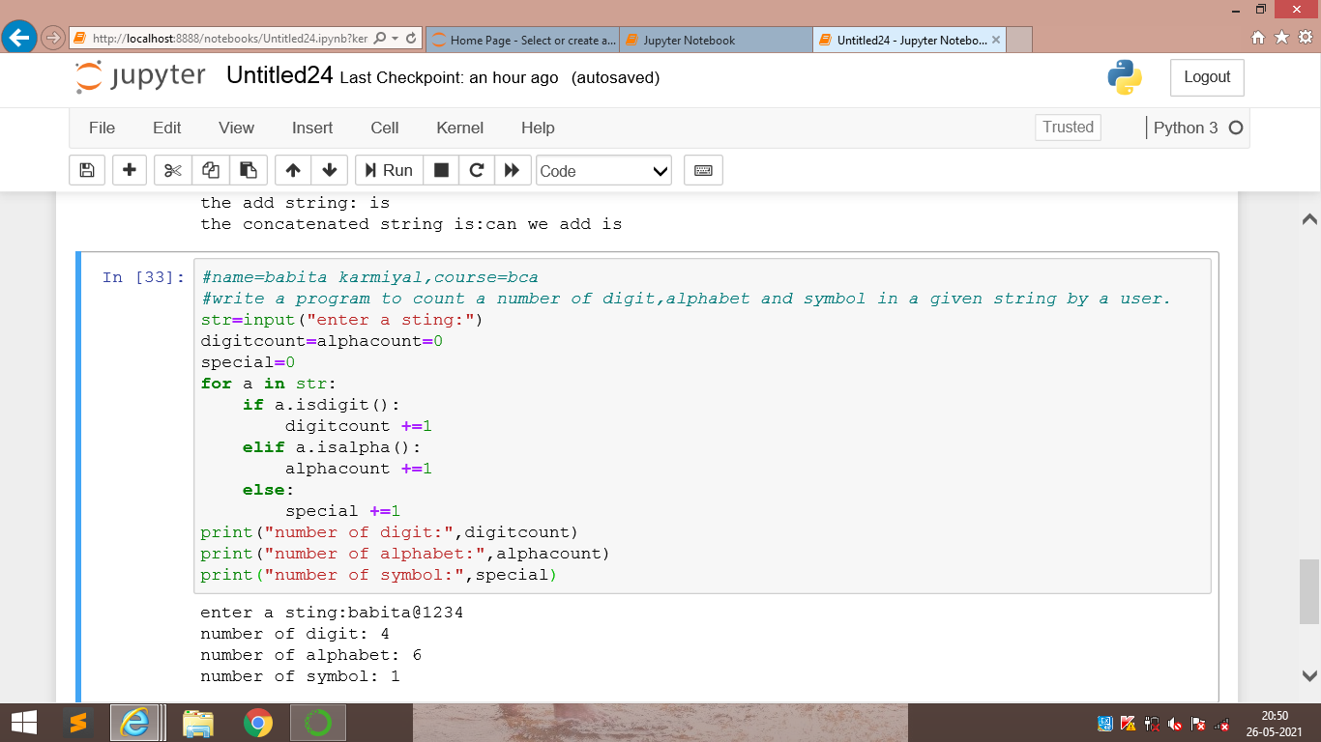

4.take two dates of same months and same year from the user in the format dd/mm/yy.now compare only the dates and calculate the number of days between the two dates and also print which date comes first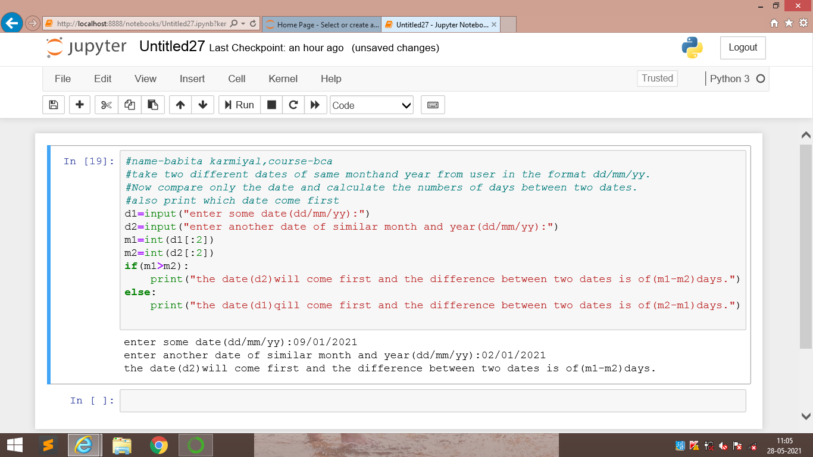

5.a student is not allowed to sit in exam ,if his/her attendance is less than75%.take following inputs from the user:

a)number of classes held

b)number of classes attended

print the percentage of class attended and also tell if h/she will sit in the exams.

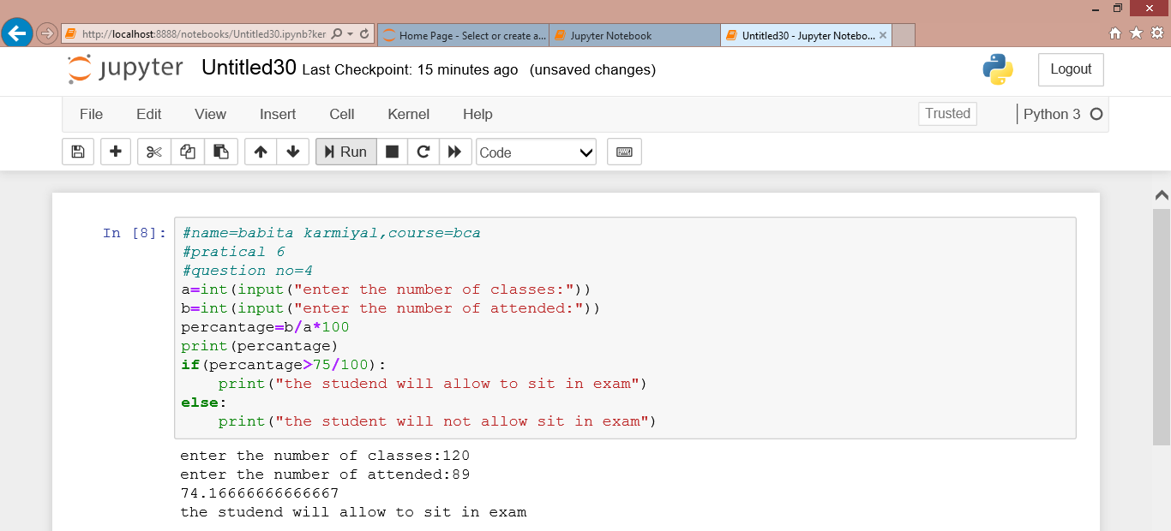

python practical question:7

1.write a python program having a user defined function which will calculate the total number of vowels in a string given by the user.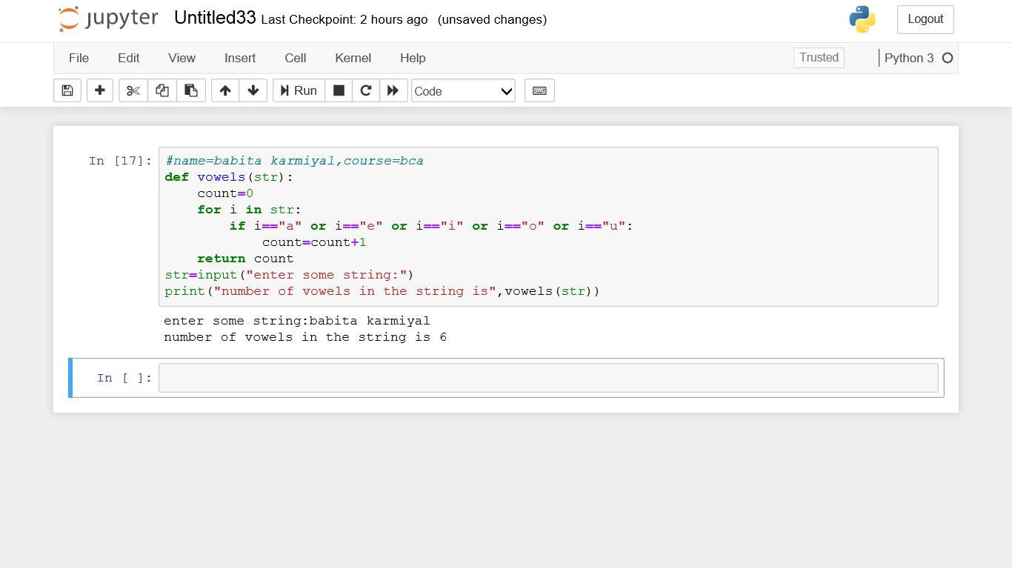

2.a shop will give discount of 10% if the cost of the purchased quantity is more then 1000 rupees.now write a python on program having a user defined function which will first calculate whether the purchased quantity is more then 1000 rupees or not and then accordingly it will print the total cost for the user.

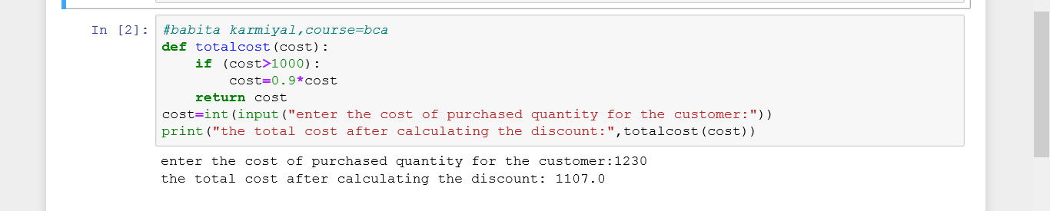

3.suppose a company dcided to give a bonus of 5% to their employee if his /her year of service in the company is more than 5 year.now rite a python program having a usr define function which will print the net bonus amount .ask user to input the salary and the year of service